Lab Report

Your Information
Your Name: Joshua Zimmerman-Gibson
Assignment Title: Advanced Excel Data Analysis

Screenshots
- Load the Online Shopper Dataset Download Online Shopper Datasetinto Excel. Add a column to the table containing your studentID.
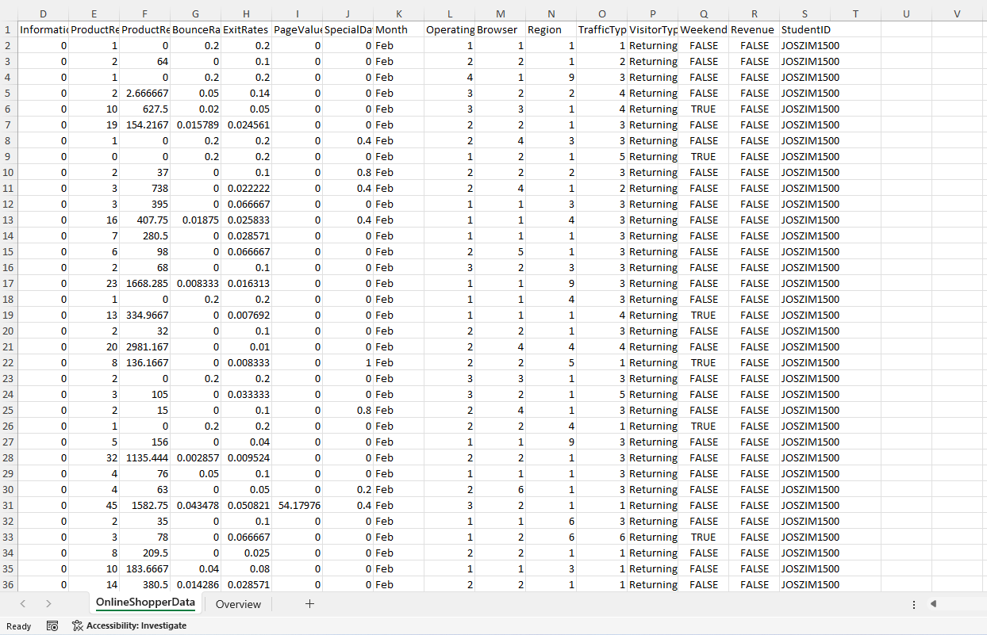
- Remove any duplicates from the dataset and check for any blanks.
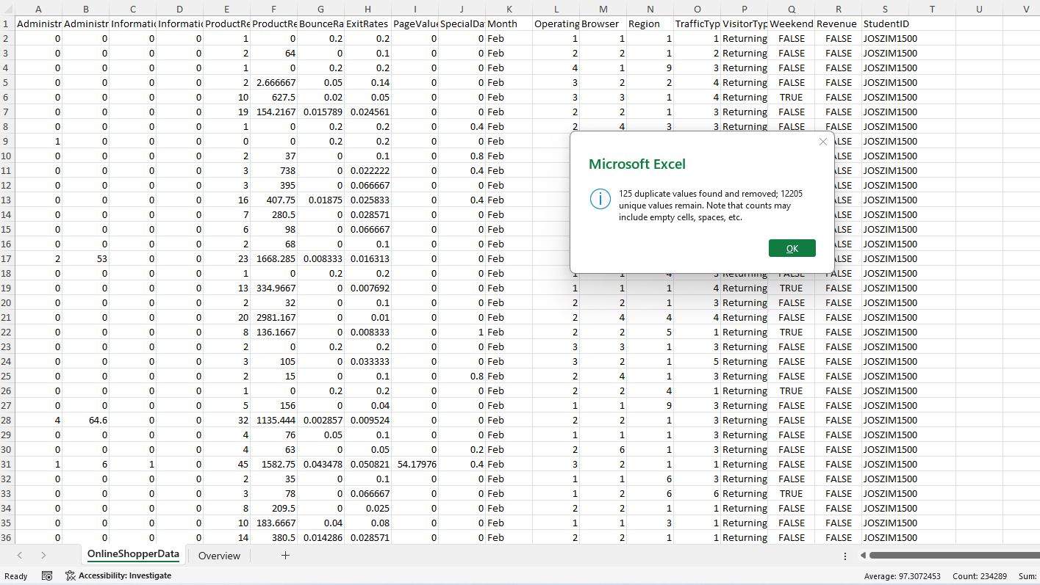
No Blanks
- Insert a new column on the OnlineShopperData sheet that displays the season associated with the month for each row. Season data is stored on the Overview sheet.
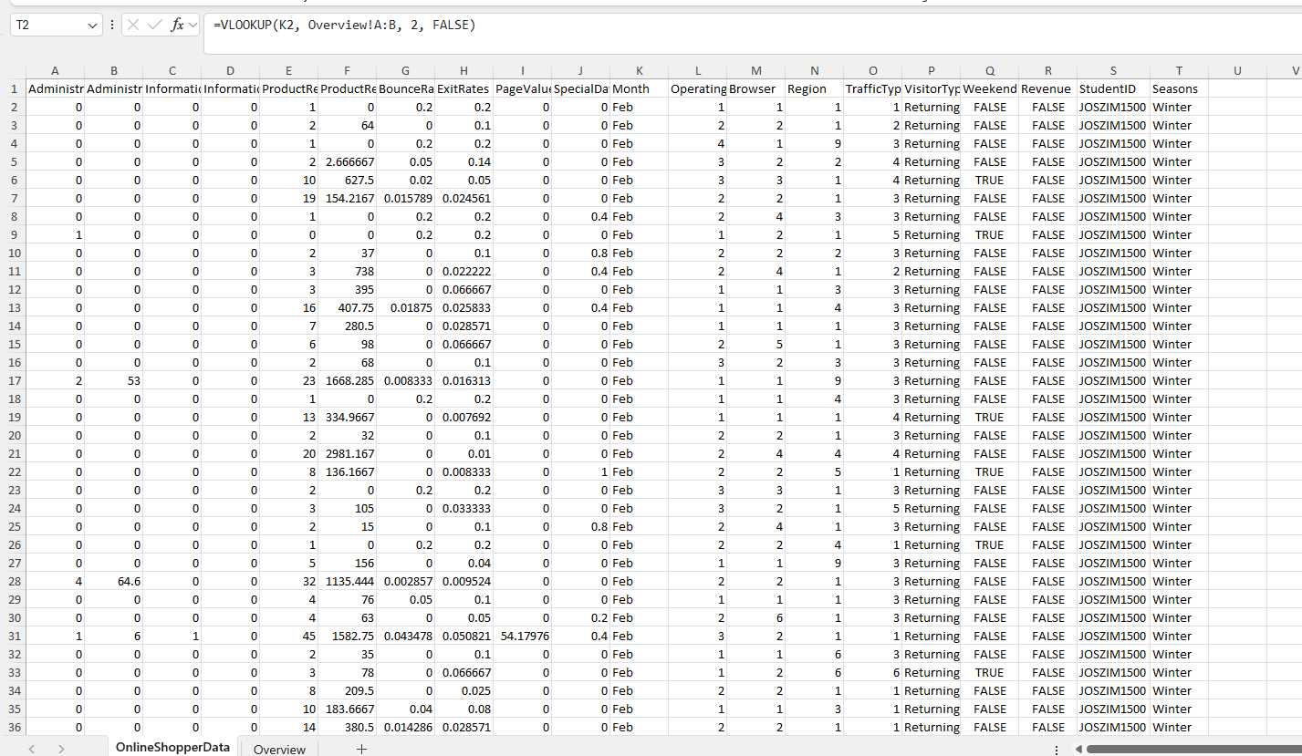
- Fill in the chart on the Overview sheet with the following information for each season:
  - Find the sum of the Administrative_Duration time spent on Operating System 1.
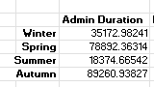
  - Find the sum of the Informational_Duration time spent on Operating System 2.
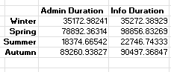
  - Find the sum of the ProductRelated_Duration time spent for new visitors.
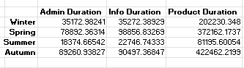
  - Find the count of new visitors where revenue was earned.
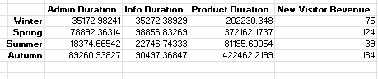
  - Find the average bounce rate for new visitors.
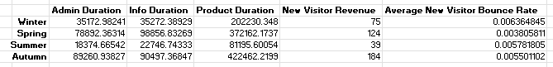
- Create a pivot table utilizing the data from the OnlineShopperData sheet. Set the columns to the seasons, set the rows to OperatingSystem, and set the values to be the sum of ProductRelated_Duration.
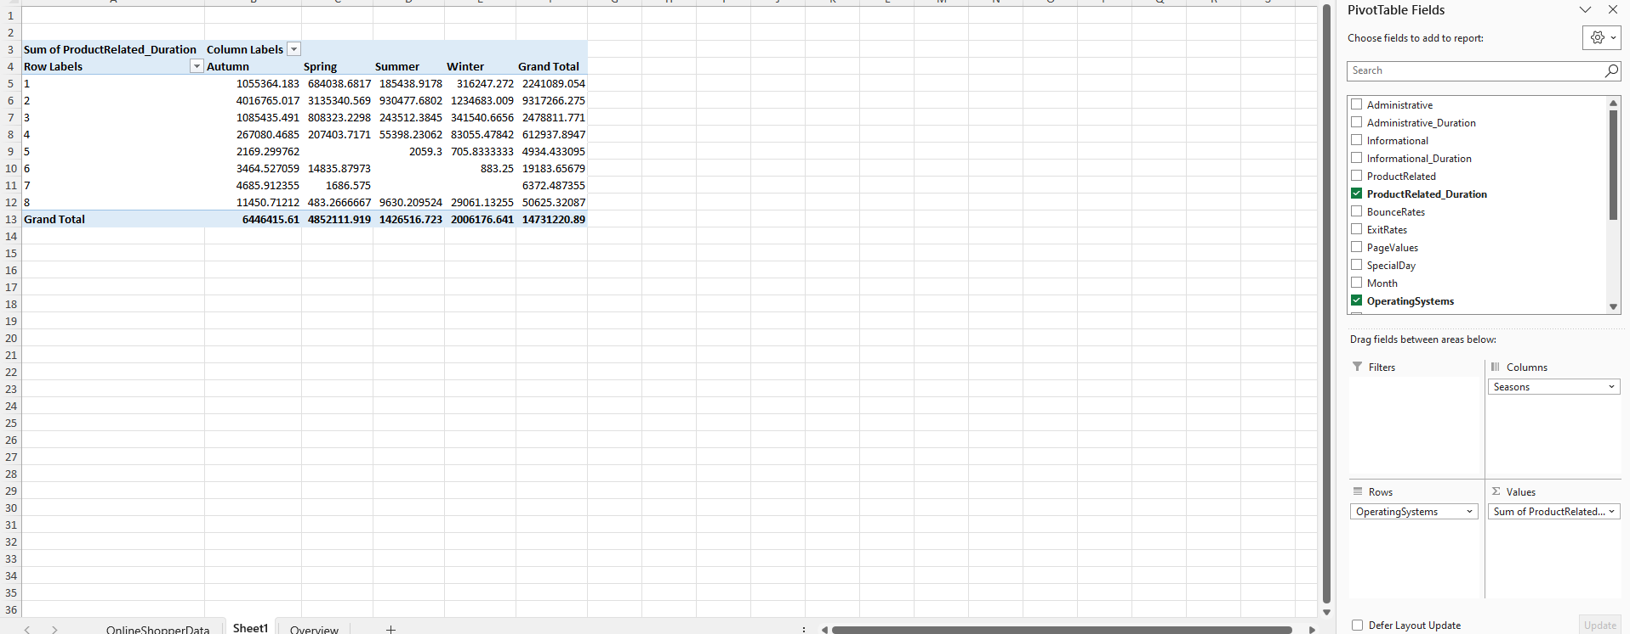
- Generate a clustered column chart from the pivot table data. Include VisitorType and Month slicers. Be sure to add your studentID and the current date to the chart title.
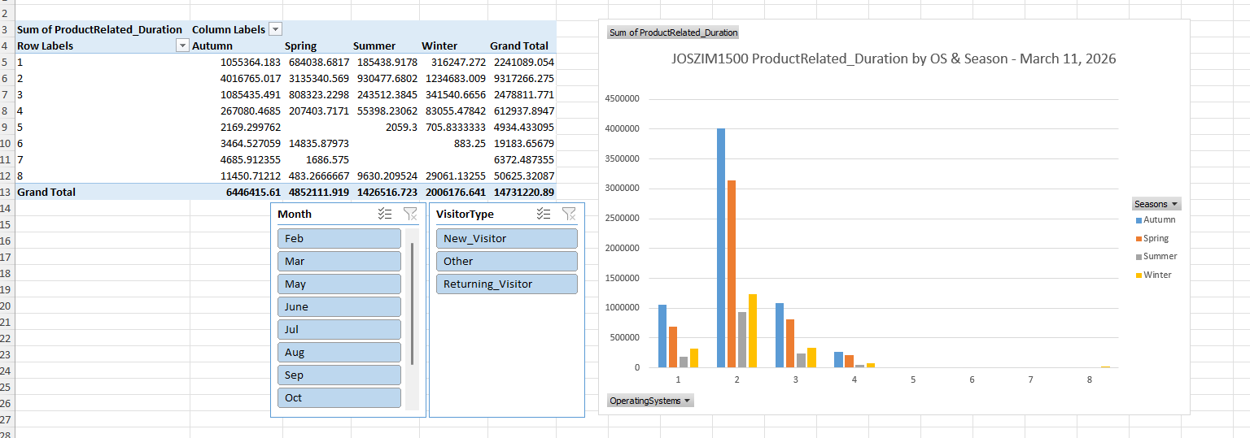

Questions
- How do pivot tables handle calculations with multiple variables?
Pivot tables summarize data by grouping fields into Rows, Columns, Values, and Filters.
When multiple variables are involved, Excel performs aggregations (such as SUM, AVERAGE, COUNT, MAX, or MIN) within each combination of row and column categories.
For example, if OperatingSystem is placed in Rows and Season in Columns, and ProductRelated_Duration is placed in Values, Excel will compute the sum of ProductRelated_Duration for every OperatingSystem–Season pairing.
This allows complex multidimensional analysis without changing the underlying dataset.

- What best practices should be followed when missing or outlier data is identified in the dataset? Use one of the fields of this dataset as an example within your response.

Identify and Confirm Issues
Use Excel tools like Filter, Conditional Formatting, or ISBLANK() to detect missing values or unusually large/small outliers.
Determine the Cause
Missing or extreme values can result from:
- incorrect data entry
- incomplete website session tracking
- system errors
Decide Whether to Remove, Replace, or Correct
- Remove if the value is clearly invalid and cannot be corrected.
- Replace using averages or medians if the missing value affects analysis significantly.
- Correct if the true value is known.
Document the Cleaning Process
Record how and why you adjusted data, so results remain transparent.

If the field BounceRate contains an unusually high value such as “300%,” this would be an outlier since bounce rate cannot exceed 100%.
A best practice would be to:
- check for entry or formula errors
- remove or correct the value
- ensure no other similar anomalies exist
This preserves the accuracy of later analyses, such as calculating the average bounce rate for new visitors.

- What purpose do slicers serve in chart visualizations? What other fields would pose useful data to slice by in question #6, and why?

Slicers allow users to interactively filter charts and pivot tables without modifying the underlying data. They create:
- Visual buttons for quick filtering
- Easy comparison between categories
- Cleaner, more dynamic dashboards
They are especially helpful in dashboards containing multiple charts or pivot tables based on the same dataset.

Additional Useful Fields to Slice By
VisitorType
Helps compare behavior between New Visitors, Returning Visitors, and Other types.
Month
Enables analysis of monthly seasonal patterns in browsing behavior.
Revenue
Allows you to filter the chart to show only sessions that resulted in a purchase—useful for identifying what behaviors contribute to conversions.
Browser
Lets you examine how performance differs across user technology preferences.

Each of these fields gives additional ways to explore the relationships between user behavior and shopping outcomes, making your analysis more actionable.

